# Hands-on tasks :

## 

Start html:

<!DOCTYPE HTML>

<html>

<head>

<meta charset="utf-8" />

<title>App</title>

<meta name="viewport" content="width=device-width, initial-scale=1" />

</head>

<body>

<h1 class="hello" style="height:100vh;">Hello!</h1>

<img class="img" src="https://smartcdn.prod.postmedia.digital/financialpost/wp-content/uploads/2014/10/dilbert.jpg" alt="Girl in a jacket" width="500" height="600">

<div class="button" style="width:50px; height:50px;background-color: red; ">

</div>

<div style="height: 400px;background-color: blue;"></div>

</body>

</html>

1. The button should be right bottom and should not be scrolled with the page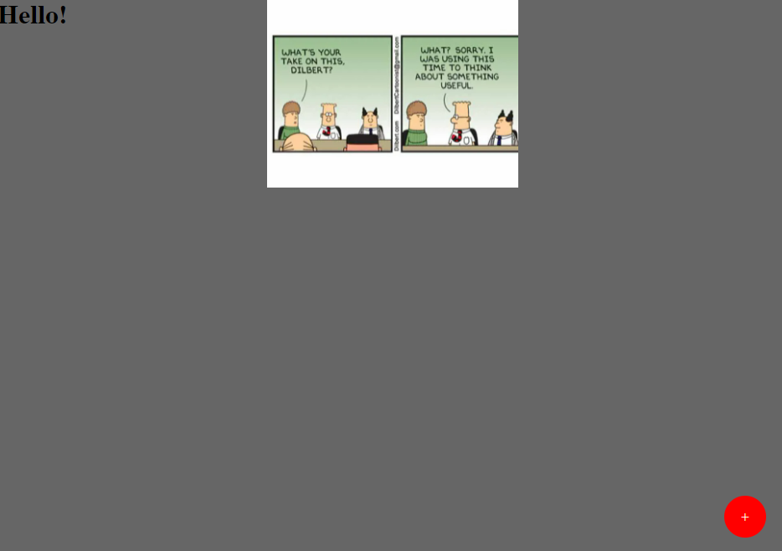

2.1) The button should be centered and scrolled with the page

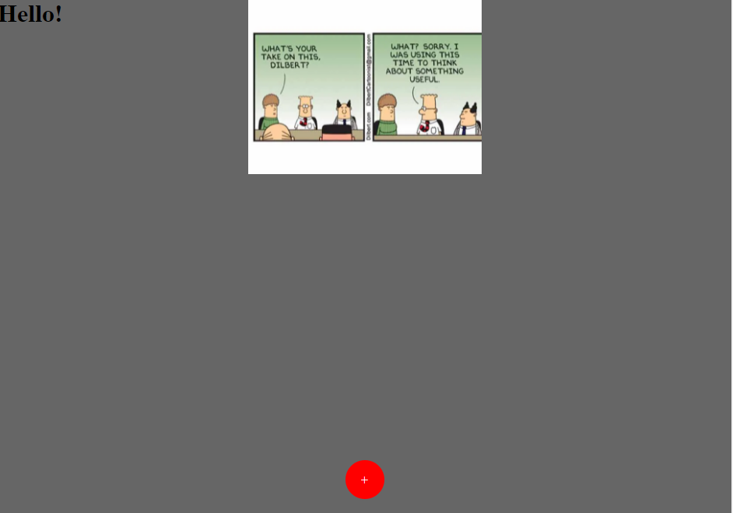

## Text highlight

We have a plain input text that looks something like this:

Prospect 0:00

Hello.

Agent 0:01

Hi, Kiara. This is Almer with Acme. How are you doing?

Prospect 0:05

You're doing good from there. I didn't get it.

Agent 0:09

From Acme. We're a carrot platform I just was following up. It looks like you downloaded our Thank God.

Prospect 0:15

Yeah. Look at it. Luck.

Agent 0:22

Yeah.

Prospect 0:23

But I really didn't get a chance to look at it yet.

….

We need to highlight some parts of the text and add display “meta data” below it.

The highlighted parts will be based on a json that describes:

* The position ([start, end]) of the text to be highlighted
* The background color for each highlighted text
* A label text that should be displayed under the highlighted text

**Requirements**: :

* The output text should keep the input text format (e.g keep newlines)
* Each

